How to capture Screenshot in Selenium webdriver

For taking screenshots Selenium has provided [TakesScreenShot](https://seleniumhq.github.io/selenium/docs/api/java/org/openqa/selenium/TakesScreenshot.html) interface in this interface you can use getScreenshotAs method which will capture the entire screenshot in form of file then using FileUtils we can copy screenshots from one location to another location

Screenshots are desirable for bug analysis. Selenium can automatically take screenshots during execution. You need to type cast WebDriver instance to TakesScreenshot.

[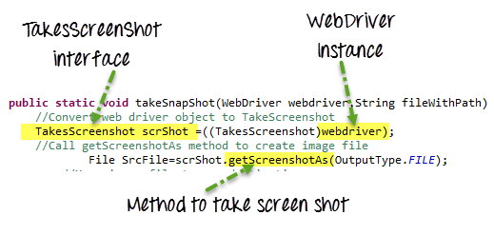](https://www.guru99.com/images/AdvanceSelenium/071514_0728_PDFEmailsan8.png)

Taking Screenshot in Selenium is a 3 Step process

**Step 1)** Convert web driver object to TakeScreenshot

TakesScreenshot scrShot =((TakesScreenshot)webdriver);

**Step 2)**Call getScreenshotAs method to create image file

File SrcFile=scrShot.getScreenshotAs(OutputType.FILE);

**Step 3)**Copy file to Desired Location

Example: In this example we will take screen capture of http://google.com/ & save it as C:/Test.png

Let’s implement the same

// Take screenshot and store as a file format

  File src= ((TakesScreenshot)driver).getScreenshotAs(OutputType.FILE);

try {

  // now copy the  screenshot to desired location using copyFile method

 FileUtils.copyFile(src, new File("C:/selenium/"+System.currentTimeMillis()+".png"));

       }

catch (IOException e)

{

System.out.println(e.getMessage());

    }